Business Improvement Program Guidelines
Recognizing that small businesses have always been a part of the East Trenton community, the East Trenton Collaborative (ETC) Business Improvement Program is intended to assist small businesses operating in the neighborhood, including retail, service, industrial, non-profit social enterprise, or real estate businesses (see map) to improve or enhance their capacity to (1) provide goods and services to neighborhood residents or (2) provide job opportunities to local residents, with the goal of helping small businesses be a more active, positive presence in East Trenton.
The East Trenton Neighborhood
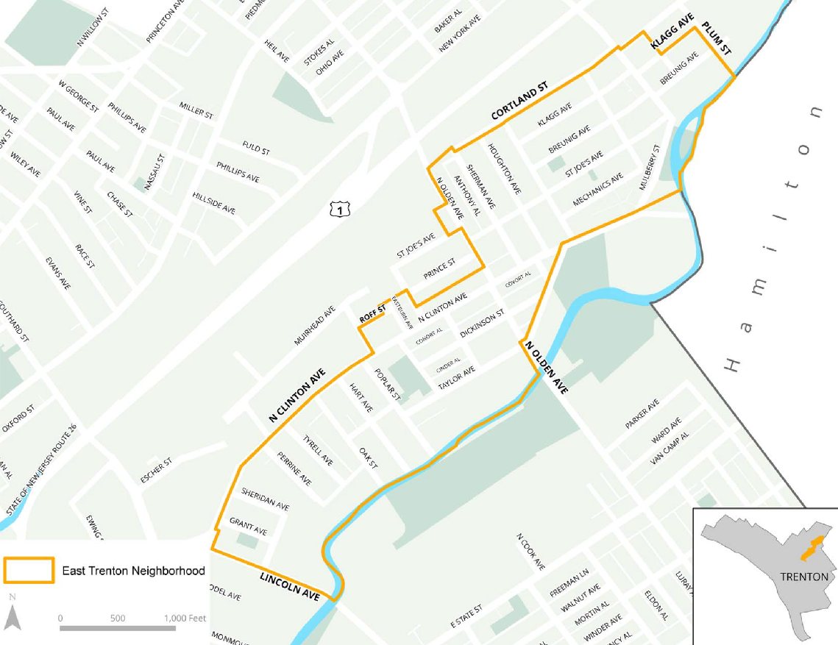

Eligibility
Only small businesses or nonprofit social enterprises that operate or demonstrate that they have a plan to operate in the East Trenton neighborhood (see map) are eligible to apply.
Eligible businesses include:
- Businesses who have or are moving into physical storefront space in the East Trenton neighborhood
  - Examples include but are not limited to restaurants, bars, grocers, liquor stores, retail stores, auto mechanics, barbershops or other service providers.

- Industrial Businesses that have manufacturing or warehouse space in the East Trenton neighborhood.
- East Trenton residents who own and operate residential rental properties and wish to add additional East Trenton properties to their rental housing portfolio.
- Business owners who currently rent space to operate their business in the neighborhood who seek to purchase mixed use commercial or industrial property to move or expand their business to.
- Nonprofit social enterprises
- Other scenarios will be considered on a case-by-case basis.
Priority will be given to businesses whose owner lives in the neighborhood, who have a significant proportion of their employees living in the neighborhood, or who are collaborating on larger neighborhood improvement efforts, though any business can apply. Rejected applicants may reapply, but businesses may only receive one grant per calendar year.
Eligible Expenses
This grant is intended to support long-term, tangible investment that will help the business become a more active and positive presence in the East Trenton community. Businesses may apply for up to $6,000 in grant funds for eligible expenses to improve or enhance their capacity to (1) provide goods and services to neighborhood residents or (2) provide job opportunities to local residents. These can include such improvements as:
Physical improvements to existing storefront or street side presence:
- Physical renovation of storefronts, including interior fixtures, lights, countertops, piping, etc.
- Renovation or improvement of facades, including side walls that face the street, as well as signage, awnings, outdoor seating space, etc.
- Lights or other security equipment
Acquisition of space for conducting business
- Financial assistance to defray the associated costs of purchasing and fitting out a property, including down payment, appraisal, architectural or structural engineering, trash out, or other expense
  - Note: Assistance purchasing residential properties for rental is available only to East Trenton residents who currently live in East Trenton and who are seeking to purchase properties in the East Trenton neighborhood. Assistance is available to others seeking to purchase mixed-use, commercial or industrial businesses who are currently operating businesses in the East Trenton neighborhood. Other scenarios will be considered on a case-by-case basis.
Improvements to business operations and capacity
- Training or consulting services to strengthen the business
- Technology, such as sales tracking or accounting software, or other media development such as website design
- Purchase or repair of equipment that is critical to the business, particularly if it will enable the business to employ additional people, extend its hours, or otherwise become more active and successful.
This list is not exhaustive, and applications will be reviewed individually. Businesses should understand this program as an investment in their physical, visible presence in East Trenton. Applicants should also check to see if they are eligible for small business improvement funding from the City of Trenton.
The grant cannot support operating expenses, including the following:
- Salaries or wages,
- Operating inputs, such as raw materials or consumables
- Inventory for sale
- Debt reduction, back taxes, or other financial liabilities
- Marketing, advertising, etc.

Owner match
If the applicant is requesting more than $1,500 in grant funds, the applicant must show that they are “matching” the grant with an investment of their own time or resources. This can include covering a portion of the proposed work out of pocket, doing some of the work themselves ‘in-kind’, documenting the cost of physical repairs the business has already carried out within the past six months, participating or supporting community events in the neighborhood, hiring East Trenton residents when possible, being a placement site for ETC’s Youth Employment Program, , or ‘paying it forward’ by assisting another neighborhood business owner with a challenge they are having. Group these
There is no set match proportion, but applicants that show a larger match or greater commitment will be given priority and have a higher likelihood of receiving the grant. The intent is to assist businesses that are making their own investment of time or money in the neighborhood.
Grant Timeline
- This program is intended to have rapid, visible results. Grantees are expected to do all work within 90 days of their grant agreement.
- Grantees will receive one-half of their grant amount in advance, upon signature of their grant agreement. The balance will be released upon the submission of a satisfactory final report and a site visit from the East Trenton Collaborative, to verify progress. This payment set up may be altered if needed on a case by case basis depending on circumstances (ex: an up-front payment required for a training); please let an East Trenton Collaborative staff member know if you think your situation merits this to see if you would quality.
If a grantee requires an extension for exceptional circumstances, the request must be submitted in writing to the Small Business Committee at least one month before the end of the grant period along with a detailed justification. The Small Business Committee will review the request and approve or reject it. Only one extension of up to two months will be given.
If the grantee is unable to complete the project within the approved timeframe, they will be required to return the full amount of the grant to ETC.
How to Apply
- Complete the application form, with information about your business, the proposed work, and the total budget for the improvements. The application form begins on page 5.
- Attach the following required documents:
For physical improvements to existing storefront or street side presence
- Photographs of the existing storefront and any other relevant items (equipment to be purchased, fixtures to be repaired or replaced, etc.)
- A design sketch of what will be built / repaired, if applicable
- A timeline of when the repairs/improvements will be completed
- An official quote for the proposed work or equipment from a qualified contractor or vendor
- Documentation of your “match” – the amount you will be contributing from your own resources. This can mean covering a portion of the total cost of your project, documenting recent physical renovations you have made to your storefront in the past six months, or describing your contributions to community projects or activities in East Trenton.
- The written agreement of the landlord, if the business does not own the building.
For acquisition of space for conducting business
- Photographs of the space to be acquired
- A design sketch or description of how the space will be used
- A timeline of when the acquisition will be completed
- Contract of sale or other documentation of intent to acquire the property as well as sale price
- Documentation of your “match” – the amount you will be contributing from your own resources. This can mean covering a portion of the total cost of acquiring or renovating the property.
For improvements to business operations and capacity or business startup support
- Description of scope of services of training provider or consultant, technology, or equipment to be purchased.
  - Description of how the training, consultation, technology, or equipment will improve business operations/capacity.
- Documentation of the cost of training, consultation, or purchase of technology or equipment.
- Documentation of your “match” – the amount you will be contributing from your own resources. This can mean covering a portion of the total cost of your project, documenting recent physical renovations or investments you have made to your storefront or business in the past six months, or describing your contributions to community projects or activities in East Trenton.

Applications can be submitted in hard copy to the East Trenton Collaborative during regular working hours, or via email to etc@urbanpromisetrenton.org.
Application Review
Applications will be reviewed by ETC’s Business Improvement Committee, which will schedule a site visit and interview with the business owner, and will additionally verify that the property is current on its City of Trenton property taxes (if applicable). The committee may request modifications to the proposed work, request additional documentation, or recommend only a portion of the request for funding.
If the application is approved, the business will be required to sign a grant agreement before receiving any funds. ETC and the Business Improvement Committee reserve the right to deny any application at their sole discretion.

BUSINESS IMPROVEMENT PROGRAM GRANT APPLICATION
Applicant Information
- Applicant’s Contact Information
Business Name
Location
Owner’s Name
Business Phone
Mobile Phone
Email Address

Are you an East Trenton resident? _____ Yes _____ No
If so, what is your residential address? _____________________________________________________________
What’s the best way to contact you? _____ Email _____ Text _____ Phone

- Please describe your business in brief (types of products sold, customers served, etc.).

- How long has your business been located in the East Trenton neighborhood? _____ ____

- How many employees do you have? _____ ______

- How many of your employees live in the East Trenton neighborhood? ___________

Project Information
- Check which assistance type you are applying for:
_____ Physical Improvement (Go to Question 7, then skip to Question 10)
_____ Acquisition of Space (Go to Question 8, then skip to Question 10)
_____ Improving Operations/Capacity (Go to Question 9, then continue to Question 10)

- Physical Improvement
  - Do you own your storefront? _____ Yes _____ No

  - If not, please provide the landlord’s contact information:
Name
Address
Phone
Email address

  - Application Summary
Please provide a short description (1-2 sentences) of the proposed storefront improvement work for which you are applying.

Required attachments:
- Photographs of the current condition of the relevant parts of the storefront
- A detailed contractor cost estimate or vendor quote
- A timeline for the completion of the repairs/improvements
- Renderings or sketches of what the improvement will look like
- The written agreement of the landlord, if the business does not own the building.

- Acquisition of Space
  - Please provide information of the space to be acquired:
Current Property Owner/Seller
Address
Sale Price

  - Application Summary
Please provide a short description (1-2 sentences) of the proposed use of the property to be purchased.

Required attachments:
- Photographs of the space to be acquired
- Timeline for completing the acquisition
- Detailed description of what the space will be used for
- Contract of sale or other documentation of intent to acquire the property as well as sale price

- Improving Operation/Capacity
  - Check which assistance type you are applying for:
_____ Training _____ Consulting _____ Equipment/Technology ___________________Other (Describe)
  - Please provide information on the vendor that will provide the training/consulting/equipment/technology to be acquired:
Vendor’s Business Name
Address
Business Phone
Mobile Phone
Email Address

  - Application Summary
For Training: Please provide a short description (1-2 sentences) of the training, including what topics it will cover and who will attend.

For Consulting: Please provide a short description (1-2 sentences) of the consultant and the project the consultant will complete. (Please attach consultant’s resume or sample of past work.)

For Equipment or Technology: Please list the equipment or technology you intend to purchase and the benefit the equipment will provide to your business.

Required attachments:
- Documentation of the cost of training, consultation, or purchase of technology or equipment.
- Timeline for the completion of the training or purchase of equipment

Fund Request
Funds requested from this program:
Total cost of planned project:

Improvements (Demonstration of Match)
- Please list any improvements you have made to your business in the past 6 months or community contributions you have made, if any.

Required attachments: If you would like to claim any of these as a “match” for your grant request, please attach photographs of the improvements as well as copies of receipts.

DETAILED GRANT REQUEST
- Please list all the planned expenses for which you are requesting assistance through this grant program. Include a short name/description of the items or activities, their total cost, and the amount you are requesting for each from the East Trenton Business Improvement Program.

Please attach vendor estimates or other cost documentation.

Item | Total Cost | Amount requested from ETC

