Business Start-Up Program Guidelines
Recognizing the importance of small businesses to the East Trenton community, the East Trenton Collaborative (ETC) Business Start-Up Program is intended to assist East Trenton residents wishing to start or formalize their own business. Interested residents may apply for up to $2,000 in grant funding for costs directly related to starting a new business.
The East Trenton Neighborhood
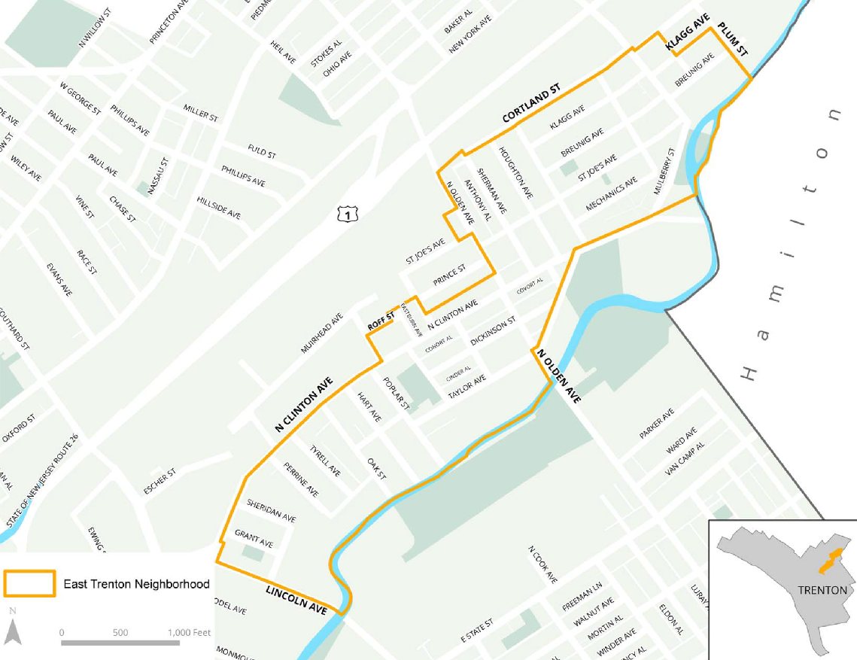

Eligibility
Only prospective entrepreneurs starting a business or nonprofit organizations working to create a social enterprise that will operate in the East Trenton neighborhood (see map) are eligible to apply.
Eligible applicants include:
- East Trenton residents planning to start a new retail or service operation in the East Trenton neighborhood
  - Examples include but are not limited to restaurants, grocers, retail stores, auto mechanics, barbershops or other service providers.
- East Trenton residents who currently have an informal “side hustle” or entrepreneurial venture that they are looking to formalize and expand
- East Trenton residents who are looking for guidance/training on how to start their own business
- Other scenarios will be considered on a case-by-case basis.
Only East Trenton residents who are planning to start or formalize their own business are eligible to apply. Rejected applicants may reapply, but entrepreneurs may only receive one grant per calendar year. Applicants must have an existing business plan, have completed a business development course or be enrolled in a business development course in order to apply.
Eligible Expenses
This grant is intended to provide targeted investment that will help new businesses get off to a good start and become an active and positive presence in the East Trenton community. Entrepreneurs may apply for up to $2,000 in grant funds for eligible business start up expenses such as:
Attaining necessary permits, licenses or training to formalize a new business
- Attaining LLC status
- Applying for the necessary permits to legally conduct business
- Enrolling in classes that are required to attain permits or licenses
- Other business development classes or trainings
Cost of obtaining space for conducting business
- Financial assistance to defray the initial costs of leasing and fitting out a storefront or other property for use by the business, including first month’s rent, space fit out or other related expense

Investment in equipment and infrastructure for starting a new business
- Equipment such as a computer, cash register, credit card reader, refrigerator, etc.
- Technology, such as sales tracking or accounting software
- Website design and development
Necessary supplies, materials or initial inventory
- Purchasing materials or inventory for a new business, such as bottles for a juicing business
Roll out of an initial marketing campaign
- Website design or construction
- Creation of promotional materials such as flyers or postcards
- Targeted social media adds
This list is not exhaustive, and applications will be reviewed individually. Grant requests exceeding $2,000 (but no higher than $6,000) will be considered on a case by case basis. Entrepreneurs should understand this program as an investment leading to their eventual physical, visible presence in East Trenton.
The grant cannot support operating expenses, including the following:
- Salaries or wages,
- Operating expenses such as WiFi or rent (beyond first month’s rent or deposit)
- Debt reduction, back taxes, or other financial liabilities

Grant Timeline
- This program is intended to have rapid, visible results. Grantees are expected to do all work within 90 days of the signing of their grant agreement unless otherwise specified.
- Grantees will receive one-half of their grant amount in advance, upon signature of their grant agreement. The balance will be released upon the submission of a satisfactory final report and a site visit from the East Trenton Collaborative, to verify progress. This payment set up may be altered if needed on a case by case basis depending on circumstances (ex: an up-front payment required for a training); please let an East Trenton Collaborative staff member know if you think your situation merits this to see if you would quality.
If a grantee requires an extension for exceptional circumstances, the request must be submitted in writing to the Small Business Committee at least one month before the end of the grant period along with a detailed justification. The Small Business Committee will review the request and approve or reject it. Only one extension of up to two months will be given.
If the grantee is unable to complete the project within the approved timeframe, they will be required to return the full amount of the grant to ETC.
How to Apply
- Complete the application form, which begins on page 4, with information about your goals for starting your business, the start up items you need, your projected costs and any items below that apply to your situation.
For attaining necessary permits, licenses or training to formalize a new business
- Copies of the permit, license, or other required paperwork before it is submitted
- A timeline of when the necessary paperwork will be completed and approved
- Description and quotes from any required classes or trainings
- Description of scope of services of any other training provider or consultant and documentation of cost
For obtaining space for conducting business
- Documentation of your rent/lease amount/arrangement;
- Estimate from a qualified contractor for improvements or fit out needs for space.
For investment in equipment and infrastructure
- Description of the equipment, technology or technical support to be acquired
- Documentation of the cost of purchasing the equipment, technology or technical support
For purchasing necessary supplies, materials or initial inventory
- Description of the supplies/materials needed
- Documentation of the cost of the supplies/materials
For the roll out of an initial marketing campaign
- Initial marketing plan and documentation of costs associated with those activities
- Estimate from a qualified third party website designer
- Quote for the creation of any other promotional materials

Applications can be submitted in hard copy to the East Trenton Collaborative during regular working hours, or via email to etc@urbanpromisetrenton.org.
Application Review
Applications will be reviewed by ETC’s Business Improvement Committee, which will schedule an interview with the prospective business owner and site visit if applicable. The committee may propose modifications to the proposed budget and set of activities, request additional documentation, or recommend only a portion of the request for funding.
If the application is approved, the entrepreneur will be required to sign a grant agreement before receiving any funds. ETC and the Business Improvement Committee reserve the right to deny any application at their sole discretion.

BUSINESS IMPROVEMENT PROGRAM GRANT APPLICATION
Applicant Information
- Applicant’s Contact Information
Planned Business Name
Location
Owner’s Name
Business Phone
Mobile Phone
Email Address

Are you an East Trenton resident? _____ Yes _____ No
If so, what is your residential address? _____________________________________________________________
What’s the best way to contact you? _____ Email _____ Text _____ Phone

- Please describe your planned business in brief (types of services or products you will sell, customers you will serve, etc.).

- If already operating informally, how long has your business been located in the East Trenton neighborhood? _____ ____

Project Information
- Check which assistance type you are applying for, as well as which additional documentation you will be providing:
_____ Attaining Permits or Licenses
Required attachments (check if applicable):
- Copies of the permit, license, or other required paperwork to be submitted
- A timeline of when the necessary paperwork will be completed and approved
- Description and quotes from any required classes or trainings

_____ Obtaining Space for Conducting Business
Required attachments (check if applicable):
- Photographs of the space to be rented/leased
- Timeline for obtaining the space
- Detailed description of what the space will be used for
- Lease or other documentation of intent to rent the property as well as the price
_____ Investment in equipment and infrastructure
Required attachments:
- Description of the equipment, technology or technical support to be acquired and how it will help you start your business
- Documentation of the cost of purchasing the equipment, technology or technical support/training
- Timeline for the completion of the training or purchase of equipment
_____Purchase of necessary supplies, materials or initial inventory
Required attachments:
- Description of the supplies/materials needed
- Documentation of the cost of the supplies/materials
_____ Initial marketing efforts
Required attachments (include those that apply to your request):
- Initial marketing plan and documentation of costs associated with those activities
- Estimate from a qualified third party website designer
- Quote for the creation of any other promotional materials

_____ Other (Please provide description): ___________________________________________________________________

- Application Summary
Please provide a short description (1-2 sentences) about the assistance you are applying for

- Please describe how the assistance selected above will help you to build your planned business.

Funding Request
Funds requested from this program:
Total cost of business start up plan:

DETAILED GRANT REQUEST
- Please list all the planned expenses for which you are requesting assistance through this grant program. Include a short name/description of the items or activities, their total cost, and the amount you are requesting for each from the East Trenton Business Start Up Program.

Please attach vendor estimates or other cost documentation, and any other documents or information listed above that applies to your request.

Item | Total Cost | Amount requested from ETC

