ETC Lead Service Line Replacement (LSLR) Grant Program
Exposure to lead in drinking water can lead to serious health problems including damage to the kidneys and brain. Infants, children and pregnant women are especially at risk. Trenton Water Works (TWW) has launched a Lead Service line (LSL) Replacement Program to help eliminate this risk to residents in its service area. Over the next year, TWW will replace at least 3,900 service lines to homes throughout its service area with a lead-free copper service line. TWW is replacing the public side of the utility line at no cost to residents. However the replacement of the resident owned side of the utility line will come with a cost of $1000 to homeowners, to be billed in quarterly installments of $50 over a five-year period. To ensure that as many residents as possible have access to lead free drinking water, the East Trenton Collaborative (ETC) has secured funding to provide subsidies to East Trenton residents who need to have their lines replaced.

The East Trenton Neighborhood
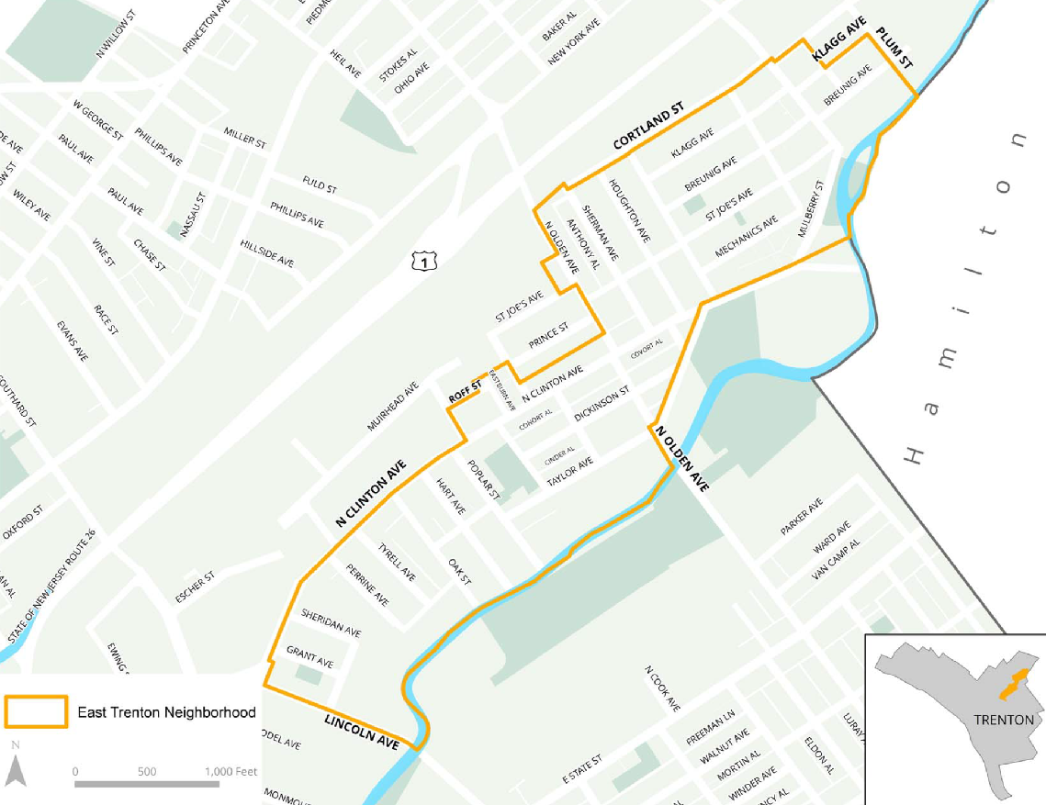

Eligibility

Homeowners in the East Trenton neighborhood (see map) who have registered for the Lead Service Line Replacement program and had their service line materials verified as needing replacement are eligible to apply for a 100% subsidy, or the full $1,000. Landlords with properties in the East Trenton neighborhood who have registered for the LSLR program and had their service line materials verified as needing replacement are eligible to apply for a 50% subsidy, or $500. Grants will be awarded on a first come first serve basis while funds remain available.
Eligible Expenses
This grant is intended to subsidize the cost of replacing owner’s side lead/galvanized service lines for privately owned residential properties in East Trenton.
Owner match
Landlords must commit to matching the 50% subsidy provided by ETC to cover the full $1000 cost of replacing the lead service line.
Grant Timeline
Applicants may apply to the program once they have registered for the LSLR program with TWW and had the material of their service lines confirmed as requiring replacement. Funds will be distributed directly to TWW upon completion of the service line replacement.

How to Apply
- Complete the application form on the next page.
- Attach the following required documents:
- Most recent water bill
- Proof of Registration for the LSLR program from TWW
- Proof of verification of service line materials (card or email from TWW stating that your service line is lead/galvanized and requires replacement.)
- Proof of ownership of the property where lines are to be replaced (Tax records or deed accepted)
- If applicable, information on the appointment for scheduled replacement
Completed applications can be submitted in hard copy to the East Trenton Center at 601 N. Clinton Avenue or via email to etc@urbanpromisetrenton.org.
Application Review
Applications will be reviewed by East Trenton Collaborative staff. Registration and Verification information will be confirmed with TWW. A grant agreement must be signed by grantee upon notification of award.

LEAD SERVICE LINE REPLACEMENT PROGRAM GRANT APPLICATION
Applicant Information

Applicant’s Contact Information

Name:

_______________________________________________

Property Address:

_______________________________________________

Phone:

_______________________________________________

Email Address:

_______________________________________________

What is the best way to contact you? _____ Email _____ Text _____ Phone

- Owner Occupant
- Landlord

LANDLORDS:
Are you an East Trenton resident? _____ Yes _____ No

Primary residence address:

________________________________________________________________

Tenant contact information:

Name:

________________________________________________________

Phone:

______________________________________

Email:

______________________________________

Project Information
Check which assistance type you are applying for:

_____ 100% Owner Occupant subsidy
_____ 50% Landlord subsidy

Required attachments:
- Most recent water bill
- Dated proof of Registration for the LSLR program from TWW
- Proof of verification of service line materials (card or email from TWW stating that your service line is lead/galvanized and requires replacement.)
- Proof of ownership of the property where lines are to be replaced (Tax records or deed accepted)
- If applicable, information on the appointment for scheduled replacement
- If applicable, signed acknowledgment of proposed work from tenant

Signature of applicant: Date:

_________________________________________ __________________

Signature of staff receiving application: Date:

_________________________________________ __________________

