East Trenton Traffic Safety Audit
East Trenton Collaborative (ETC) Staff and resident Traffic Safety Community Organizing Committee (TSCOC) members have worked to create a traffic safety audit for the East Trenton neighborhood. The purpose of the Traffic Safety audit is to provide the City of Trenton and other stakeholders with a comprehensive list of current traffic safety issues in the neighborhood and a set of recommended solutions for improving the dangerous conditions. This list may not be exhaustive but was made to collect traffic safety issues in the neighborhood and compile them in one document. The City of Trenton has been responsive in addressing several traffic safeties issues in the East Trenton neighborhood. This traffic safety audit is meant to be a way to streamline our collaborative efforts to continue to make the neighborhood a safer place for pedestrians, cyclists, and vehicles in the future.
General Recommendations:
- Add crosswalks in front of businesses, churches, community centers, and other high foot traffic areas on N. Clinton Ave, N. Olden Ave, and Mulberry Street
- Prioritize enforcement of the speed limit throughout the East Trenton neighborhood
- Install bike lanes or sharrows on less busy neighborhood routes, especially Sherman Ave leading to the D&R Canal Trail
- Stronger presence of crossing guards during school hours at busy neighborhood intersections including N. Clinton & N. Olden Ave and other intersections along N. Clinton Ave
- Add “No Parking Here to Corner” or install bollards near stop signs on streets that intersect with N. Clinton Ave & N. Olden Ave to prevent people from parking to close to intersection and obstructing views for pedestrians and drivers trying to turn onto N. Clinton Ave & N. Olden Ave
East Trenton General Crash Data (taken from DVRPC Crash Statistics):
- There have been 2 crashes defined as “killed or severe injury” (KSI) crashes in East Trenton in recent years. Both on N. Olden Ave in 2017 and 2019.
- 134 crashes on the portion of N. Olden Ave that runs through the East Trenton neighborhood
- 48 crashes on N. Clinton Ave between 2014-2020
- 18 crashes at the intersection of N. Clinton Ave and N. Olden Ave between 2014-2020.
- 17 crashes at the intersection of N. Clinton Ave, Perry Street, and Lincoln Ave between 2014-2020
- 10 crashes at the intersection of N. Clinton Ave, Mulberry Street, and Nottingham Way between 2016-2020

N. Clinton Ave and Sheridan Ave
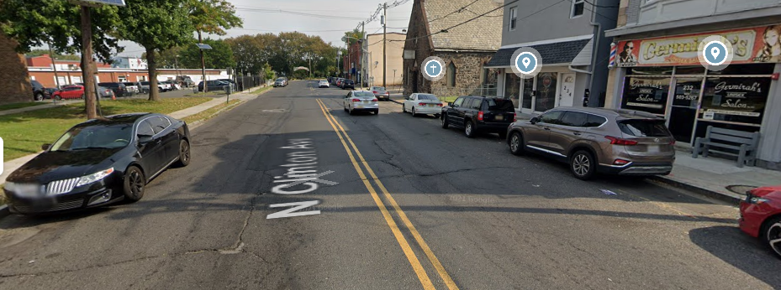
Recommendation: Adding crosswalks between N. Clinton Ave and Sheridan Ave intersection will allow for safer pedestrian crossing of N. Clinton Ave to access the Police Station, Interfaith Tabernacle Church, along with several neighboring businesses on the 200 block of N. Clinton Ave.
N. Clinton Ave in front of Capital City Farm & Police parking lot
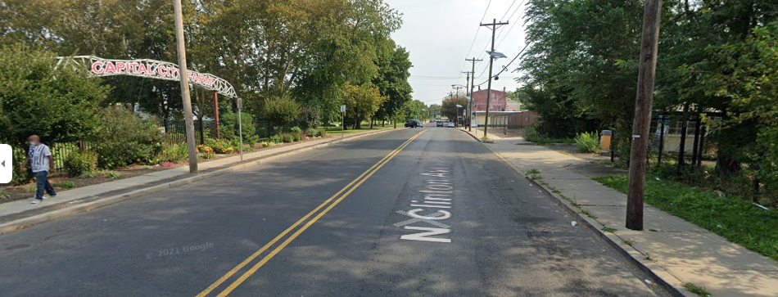
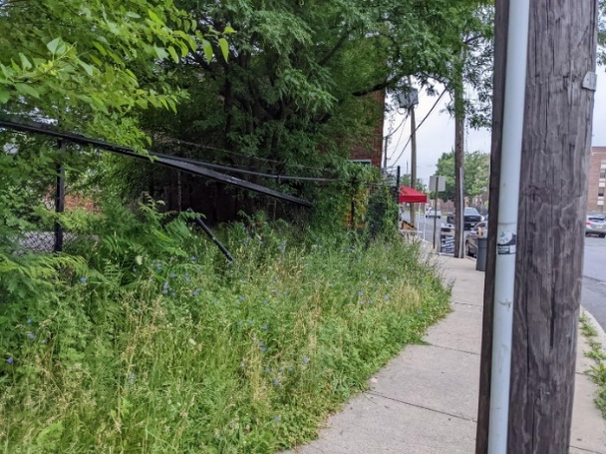
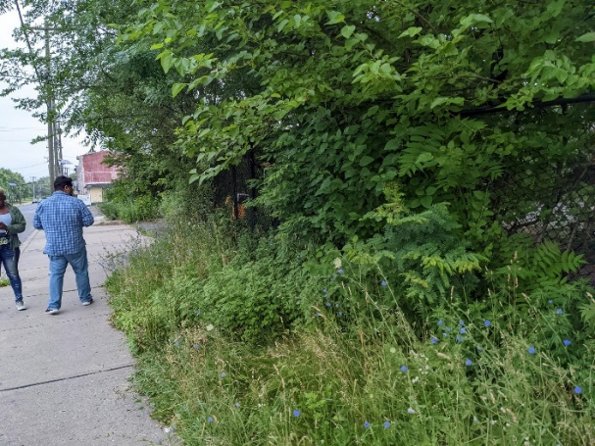

Recommendations: Adding a crosswalk or raised crossing plateau between Capital City Farm and the Police parking lot will slow traffic to allow for safer street crossing. Being across from Capital City Farm, this is a high foot traffic area. With plans to make improvements to the Police Parking Lot there will likely be an increase in foot traffic crossing N. Clinton Ave in the future. This area is also a good opportunity for a decorative crosswalk showcasing the Capital City Farm and the Assunpink Greenway. The DVRPC crash data shows that there was a pedestrian struck in 2020 on N. Clinton Ave between Sheridan Ave and Perrine Ave. Landscaping and fence repairs needed in front of the Police parking lot (272 N. Clinton Ave) to improve safety of lot and make it easier to enter/exit (in progress).
N. Clinton Ave and Perrine Ave
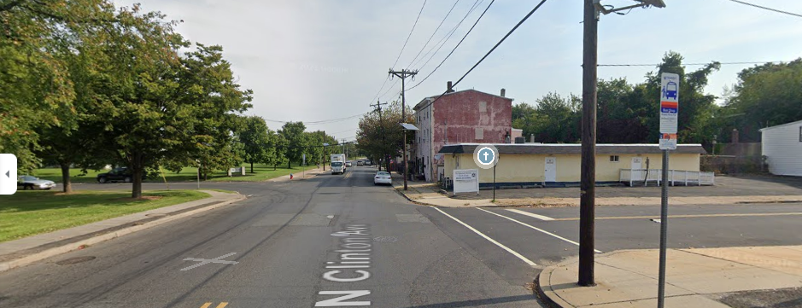
Recommendations: Adding a crosswalk between N. Clinton Ave and Perrine Ave in front of the Redeemed Christian Church of God would allow for safer street crossing for attendants of the Church
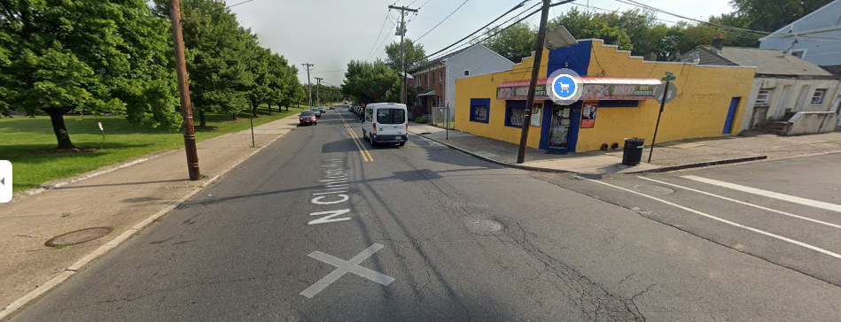
N. Clinton Ave and Tyrell Ave

Recommendations: A crosswalk is needed between Tyrell Ave and N. Clinton Ave intersection in front of Monchy Deli Grocery to allow for safer street crossing and easier access to the business. Install “No Parking Here Until Corner” sign on Tyrell Ave for trucks delivering to Monchy Deli and Grocery. Also add bollards to prevent cars/trucks from parking too close to the stop signs. Cars and delivery trucks frequently park in front of the stop sign on Tyrell Ave to access Monchy Deli and Grocery. This blocks the view of cars trying to turn from Tyrell Ave onto N. Clinton Ave.

Tyrell Ave and Amtico Square
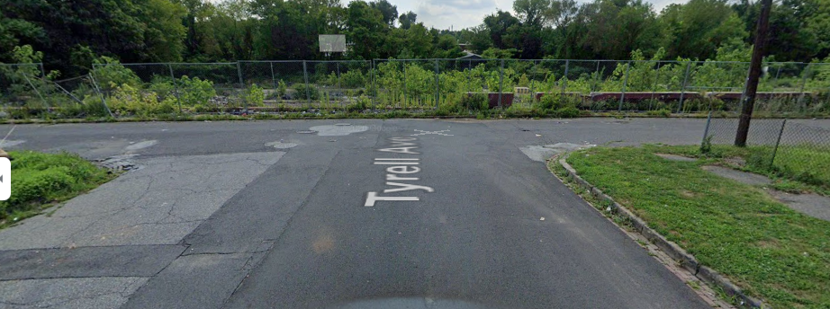
Recommendations: Install reflective signage on the fence that runs along Amtico Square so drivers are able to see it at night and know that Tyrell Ave ends, and they must turn. This will help to prevent drivers from potentially driving through the fence/wall bordering Amtico square
N. Clinton Ave and Poplar Street
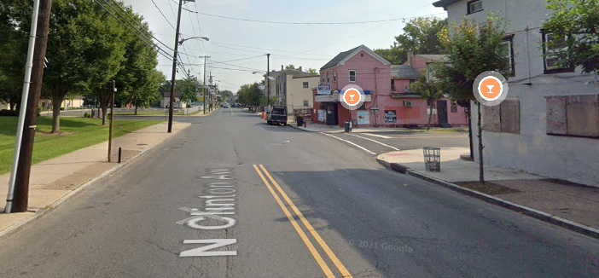
Multiple crosswalks are needed at the N. Clinton Ave and Poplar Street intersection. With bars on either side of the street, the crosswalks would allow patrons to safely cross N. Clinton Ave and access the bars
N. Clinton Ave and Church of Christ
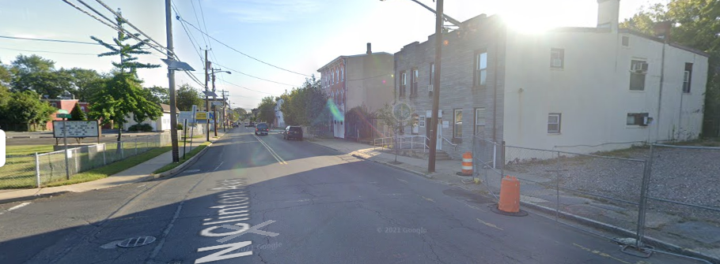
Recommendations: Adding a crosswalk on N. Clinton Ave in front of the Church of Christ to allow pedestrians to safely cross the street in the area. Speed limit signs should be added on N. Clinton Ave between Tyrell Ave and Eastburn Ave to slow traffic and allow for safer street crossings. The portion of the sidewalk in front of the Church of Christ is in very poor condition and should be replaced so that wheelchair bound residents can safely get around and do not have to be in the street.

N. Clinton Ave and Eastburn Ave
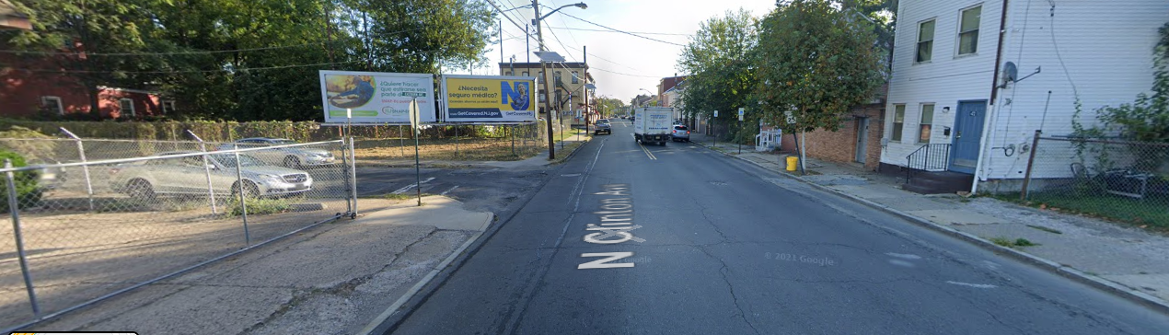
Recommendations: Add a crosswalk between Eastburn Ave and N. Clinton Ave to allow residents of Eastburn Ave to safely cross the street. Eastburn Ave also in very poor condition in general and should be repaved.

N. Clinton Ave in front of C&F Tires
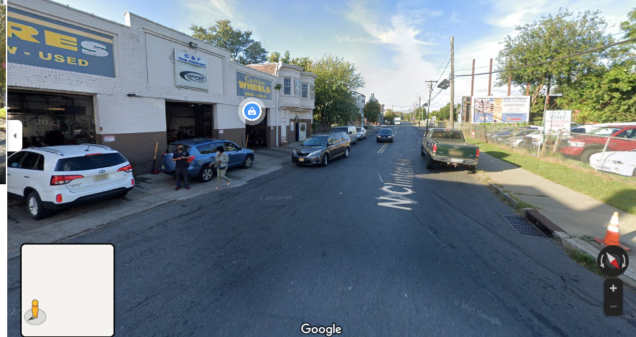
Recommendations: There is regularly significant congestion with cars coming and leaving from C&F tires that leads to low visibility in the road and street crossing hazards. We recommend working with the business to come up with a solution to improve conditions. Some options to improve traffic safety in the area could be adding “No Idling” signs in front of C&F tires, and “No parking here to corner” signs on Meade Street and N. Clinton Ave in front of the Mini Mart. According to DVRPC data, there were 8 collisions on N. Clinton Ave in the area around C&F tires between 2014-2020.

N. Clinton Ave near Nomad Restaurant
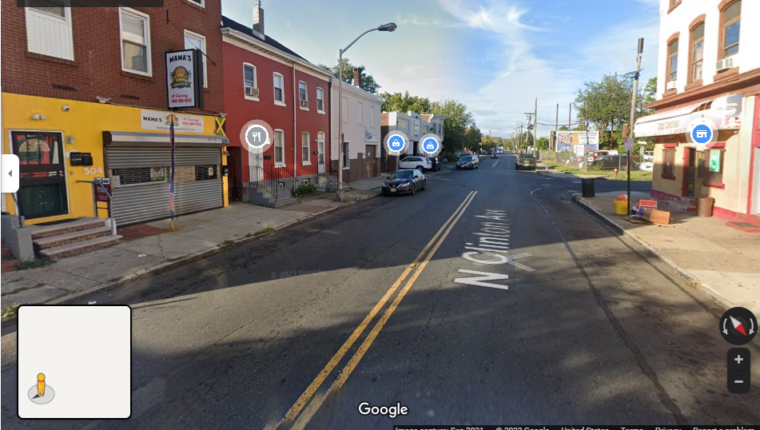
Recommendations: Add a crosswalk on N. Clinton Ave between Nomad restaurant and Mini Market to allow for safer street crossing and improve foot traffic for businesses.
N. Olden Ave
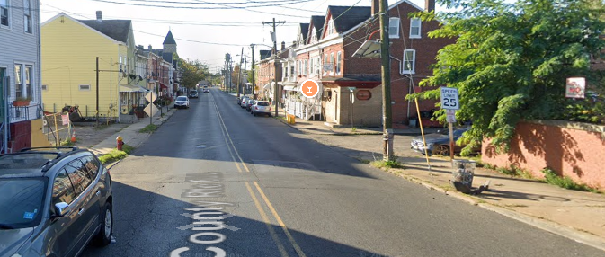
Recommendations: Add additional signage to slow down traffic as cars travel down the hill on N. Olden Ave into the residential area of the East Trenton neighborhood. Crosswalks are also needed in front of Benny’s Bistro, and St Joseph’s Church at the N. Olden Ave and Prince Street intersection. Install “No Parking Here to Corner” signs & strictly enforce on Sundays. The issues with cars parking too close to corners is most severe during Church events. N. Olden Ave had by far the most crashes of any street in the East Trenton neighborhood (143) and was the only street that had KSI crashes on it (2) according to DVRPC crash data.

N. Clinton Ave and Sherman Ave
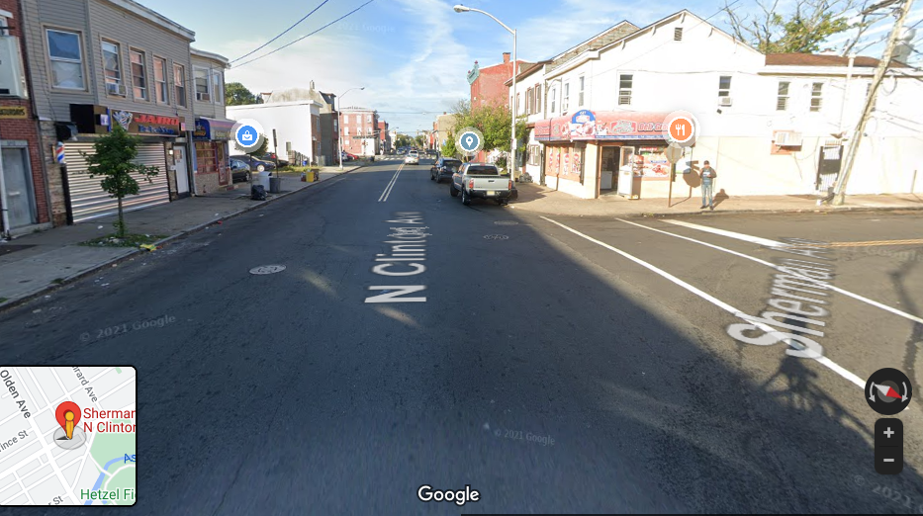

Recommendations: Add signage “No parking here to corner” on Sherman Ave, add bollards to prevent parking close to the stop sign. Cars regularly park very close to the stop sign on Sherman Ave to shop at Sabor Caribena mini market, which blocks the view for cars turning onto N. Clinton Ave making crossing hazardous for pedestrians. Add a crosswalk between Sherman Ave and N. Clinton Ave to allow for safer street crossing between Jairo Barbershop, Adriano’s Liquor Store, and Sabor Caribena mini market. There have been 4 collisions on N. Clinton Ave between Sherman Ave and Firth Street between 2019-2020 according to DVRPC collision data.

N. Clinton Ave and Houghton Ave
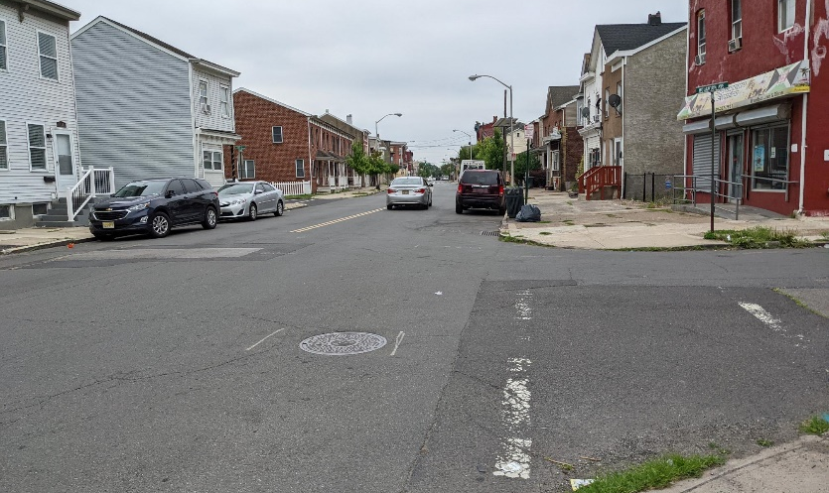
Recommendations: Adding a crosswalk between N. Clinton Ave and Houghton Ave in front of Jamaican Empire restaurant and repainting existing crosswalk on Houghton Ave to provide safer street crossing and access to Jamaican Empire restaurant.

N. Clinton Ave and Lawrence Street (George Page Park)
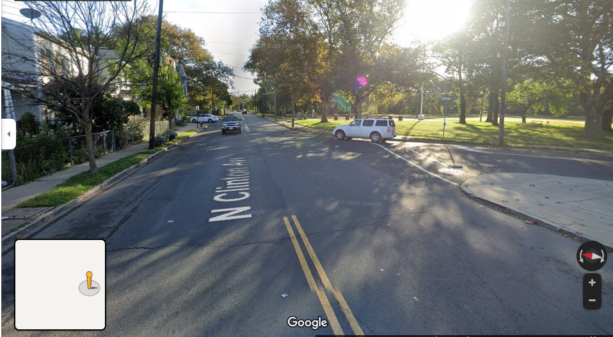
Recommendations: Adding a crosswalk between Lawrence Street and N. Clinton Ave or flashing pedestrian crossing lights to allow for safer street crossing will improve pedestrian access to George Page Park. There were 8 collisions on N. Clinton Ave between Lawrence Street and in front of George Page Park/the East Trenton Library building from 2018-2020 according to DVRPC data.
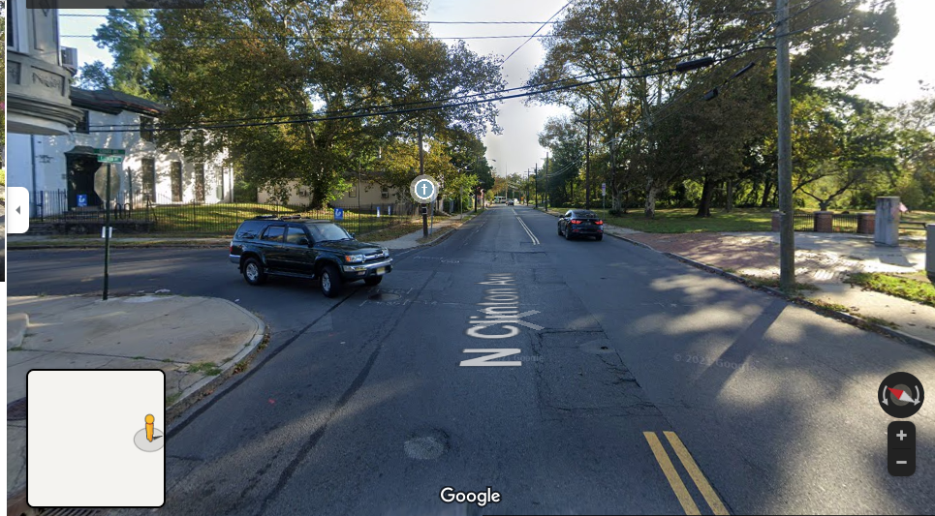
N. Clinton Ave and Girard Ave (Across from East Trenton Library building)

Recommendations: Adding a decorative crosswalk or raised crossing plateau at the intersection or flashing pedestrian crossing lights between N. Clinton Ave and Girard Ave will allow for safer street crossing. Given the plans to renovate the Library. We can expect more foot traffic in the area in the future. This space also provides an excellent location for a decorative crosswalk or raised crossing plateau to tie together the East Trenton Library building and George Page Park

N. Clinton Ave and Mulberry Street
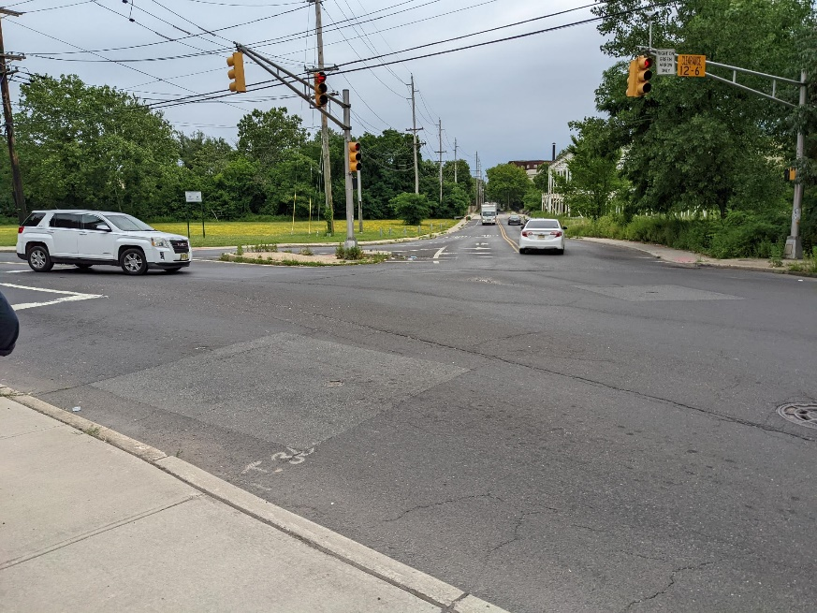

Recommendations: Adding crosswalks and repainting existing ones to allow for safer street crossings. Updated pedestrian crossing signalization would also be beneficial given the heavy traffic flow of this intersection. There have been 10 crashes at the intersection of N. Clinton Ave, Mulberry Street, and Nottingham Way between 2016-2020.
Mulberry Street
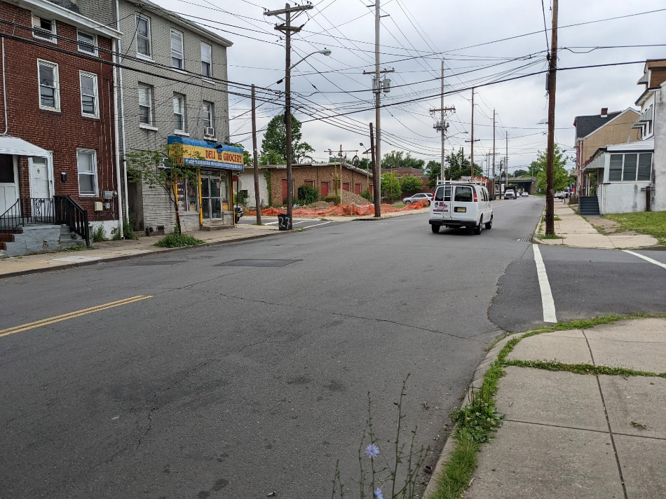
Recommendations: Adding a crosswalk on Mulberry Street in front of Mulberry Deli and Grocery Store. This is a high foot and vehicle traffic area, with cars frequently speeding on Mulberry Street after exiting Rt. 1. There have been 6 crashes on Mulberry Street in the area surrounding the Mulberry Deli and Grocery Store according to DVRPC data.
Mulberry Street and Enterprise Ave
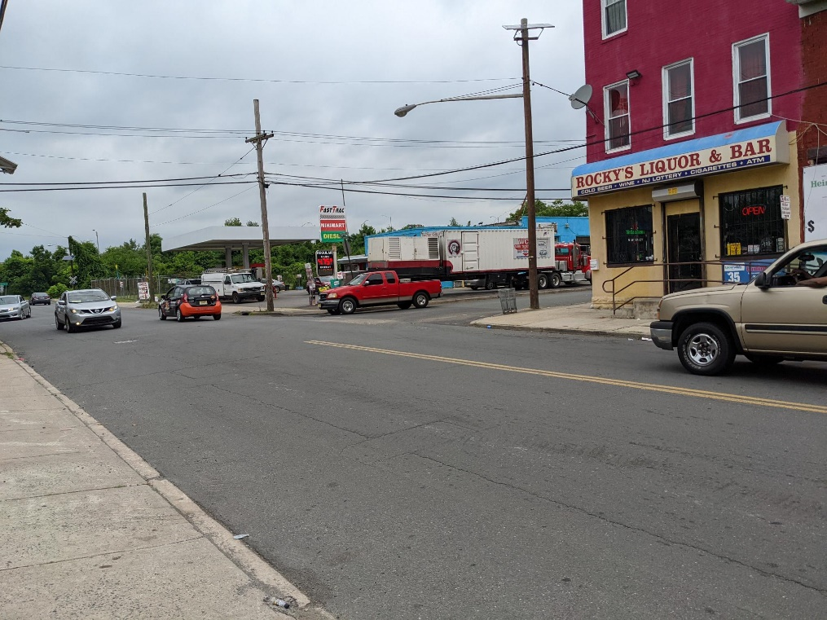
Recommendations: Adding a crosswalk on Mulberry Street at the Enterprise Ave intersection in front of Rocky’s Liquor & Bar. This is a high foot and vehicle traffic area with 2 businesses located on either side of Enterprise Ave. Cars frequently pull in and out of the Fast Trac Gas Station on Mulberry Street, and speeding is a regular issue with cars exiting Rt. 1 onto Mulberry Street adding flashing “slow down” signage could help with this issue as well. There have been 15 crashes on Mulberry Street in the area between the Trenton Water Works building and the Mulberry Street/Enterprise Ave intersection from 2014-2020 according to DVRPC crash data.
Mulberry Street Rt.1 enter/exit ramps + D&R Canal Trail crossing
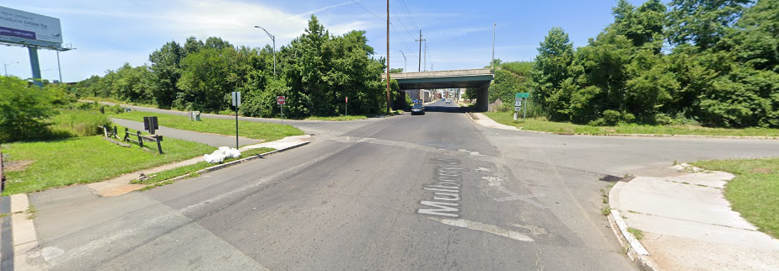
Recommendations: Adding a crosswalk or raised crossing plateau, and flashing pedestrian crossing lights on Mulberry Street in front of the Rt. 1 enter/exit ramps and the D&R Canal Trail. Pedestrians and cyclists have to cross Mulberry Street and the Rt. 1 enter/exit ramps to continue on the D&R Canal Trail on the other side of Rt. 1. Crossing Mulberry Street in this area is hazardous, as cars regularly speed when entering/exiting Rt. 1, and there are no crosswalks present on Mulberry Street or the Rt. 1 enter and exit ramps.
Girard Ave (McKnight Elementary School)
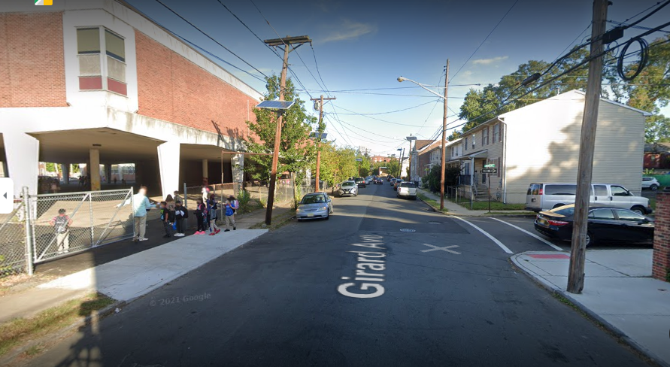
The area on Girard Ave in front of Woodrow Wilson School is hazardous for pedestrians during drop off/dismissal hours of the school day. The area becomes congested, with parents regularly double parking to pick up their children, and groups of children/parents trying to cross the street. The City should work with ETC, residents and representatives from the school to determine the best way to resolve these issues. One option that East Trenton residents have brought up in the past is to have Houghton and Girard become one-way streets and add “No truck traffic/ limited weight during school hours” signage. Additional “Children at play” signage would also help make the area around the school safer for kids as the come to and leave Woodrow Wilson School.
Klagg Ave and Girard Ave
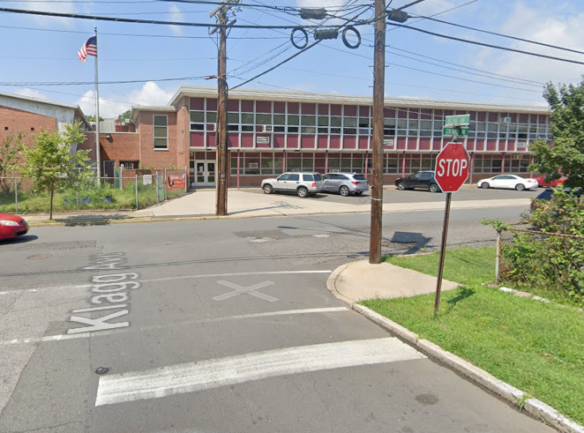
Recommendations: add “No Parking Here to Corner” signs on Klagg Ave near intersection with Girard Ave. People often park very close to the corner, especially during school dismissal times, which limits visibility and makes it dangerous to make turns from Klagg Ave. East Trenton residents have also expressed the desire to make Klagg Ave a one-way street and plan to submit petitions to the City of Trenton to do so.
Sherman Ave/Cortland Street
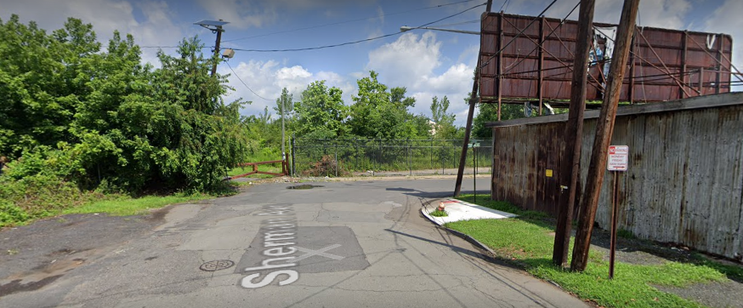
Recommendations: Adding stop signs at the end of both Sherman Ave and Cortland Street. Cars and trucks regularly speed down both streets and around the corner, posing a risk to residents in the area and limiting access to the D&R Canal Path at the Sherman Ave entrance. Consider other means of slowing down traffic on Cortland Street, such as speed bumps or improved signage. The street has a large volume of truck traffic for TWW and several industrial businesses that regularly drive recklessly in the area.
Sherman Ave and St Joes Ave
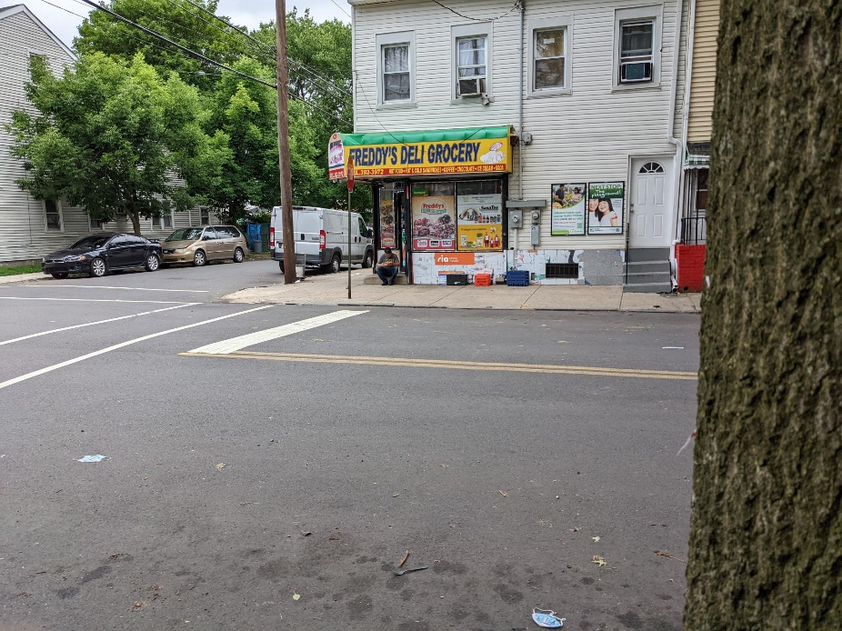
Recommendations: Adding signage “No Parking Here to Corner” and/or bollards preventing people from parking directly in front of Freddy’s Deli Grocery and blocking the view of cars trying to turn onto St Joes Ave from Sherman Ave. This issue is also particularly bad on Sundays, with people parking along Sherman Ave to attend nearby St Joseph’s Church. There were 4 crashes at this intersection in 2020 according to DVRPC crash data.

